SOUTHWEST RESEARCH INSTITUTE
6220 CULEBRA ROAD. POST OFFICE DRAWER 28510 • SAN ANTONIO, TEXAS, USA 78228-0510 • (210) 684-5111 • TELEX 244846
CHEMISTRY AND CHEMICAL ENGINEERING DIVISION DEPARTMENT OF FIRE TECHNOLOGY FAX (210) 522-3377
INVESTIGATION OF THE SURFACE BURNING CHARACTERISTICS OF A NO.2 SOUTHERN YELLOW PINE (VACUUM PRESSURED IMPREGNATED)
MATERIAL ID: NO.2 YELLOW PINE
SwRI PROJECT NO.: 01-2303-137a
FINAL REPORT
TEST DATE: 15-JAN-1999
REPORT DATE: 2-FEB-1999
Prepared for:
FLAME SAFE WOOD PRODUCTS 2653 WARFIELD AVENUE
FORT WORTH, TEXAS 76106
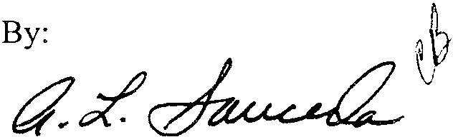
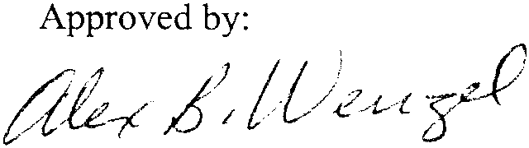
Anthony L. Sauceda Supervisor
Material Flammability Section
Alex B. Wenzel Director
Department of Fire Technology

This report is for the information of the cnent. It may be used in its entirety for the purpose of securing product acceptance from duly constituted approval authonties. This report shall not be reproduced except in full, without the written approval of SwRI. Neither this
report nor the name of the Institute shall be used in publicity or advertising.
SAN ANTONIO, TEXAS
HOUSTON, TEXAS • DETROIT, MICHIGAN • WASHINGTON, DC

INTRODUCTION
This report presents the results of a UL 1256, August 30, 1993 Edition, test on a specimen submitted by the Client. The test is conducted in general accordance with the procedure outlined in UL 1256, "Standard for Fire Test of Roof Deck Construction."
Normally, these requirements detail a method of test intended to evaluate fire performance of metallic and nonmetallic roof deck constructions subjected to an internal (under deck) small scale fire exposure for 30 minutes for the purpose of determining the contribution of the roof covering material, insulation, and other components of the roofing system to the spread of fire within a building. As the extent of flame propagation, thermal degradation, and combustive damage are determined after roof deck construction are exposed to controlled laboratory fire conditions as provided by a horizontal tunnel furnace, these requirements are not intended for use in describing or defining the fire hazard or risk of fire under actual fire conditions. For this test, the specimen consisted of fabric-covered wall panels exposed to the burner flame for 20 minutes or terminated earlier at the request of the Client.
The purpose of this test method is to determine the relative burning behavior of the material by observing the flame spread along the specimen. Flame Spread and Smoke Developed Indices are reported. However, there is not necessarily a relationship between these two measurements.
The specimen may consist of a continuous, unbroken length, or of sections joined end-to-end.
The specimen was prepared and tested as received by Client. The specimen was conditioned in an atmosphere maintained between 68 and 78 OF and 45 to 55% relative humidity.
Immediately prior to the test, the specimen is placed into the furnace and centered on the interior width so that the flame is evenly distributed over the width of the specimen and engulfs the test specimen at the 'fire end'.
The flame front position and light obscuration are recorded throughout the 30-minute test. The Flame Spread and Smoke Developed indices are calculated over the first 10-minutes of the test only. The temperature at 24 ft is also recorded.
The Flame Spread and Smoke Developed indices reported herein are relative to the results obtained for mineral fiber-reinforced cement board and select grade red oak (moisture content between 6 and 8%). The mineral fiber-reinforced cement board is the calibration material used to obtain 0 values for Flame Spread and Smoke; red oak decks are used to obtain 100 values for Flame Spread and Smoke.
The results apply specifically to the specimens tested, in the manner tested, and not to the entire production of these or similar materials, nor to the performance when used in combination with other materials.
1 of 6

---------~.~--- ~~ ---
This standard should be used to measure and describe the properties of materials, products, or assemblies in response to heat and flame under controlled laboratory conditions and should not be used to describe or appraise the fire hazard or fire risk of materials, products, or assemblies under actual fire conditions. However, results of this test may be used as elements of a fire risk assessment which takes into account all of the factors which are pertinent to an assessment of the fire hazard of a particular end use.
20f6

UL 1256 REPORT
CLIENT: FLAME SAFE WOOD PRODUCTS SWRI PROJECT NO: 01-2303-137a
DAILY TEST NO: 5
DESCRIPTION OF SPECIMEN
DATE RECEIVED:
ll-Jan-1999 (received ready-to-test)
MATERIAL ID:
No.2 Southern Yellow Pine
DESCRIPTION:
Southern yellow pine (vacuum pressured impregnated)
THICKNESS:
2.25 in. (nominal)
COLOR:
Beige
SPECIMEN SIZE:
Three decks 24.0 in. wide x 95.5 in. long
CONDITIONING TIME: 4 days at 70°F and 50% relative humidity
SUPPORT USED:
None
WITNESSED BY:
Mr. Vince Mancini of Chicago Flameproof
Mr. Louis Jacobini of Flame Safe Wood Products
*
From Client's material description
3 of 6

UL 1256 REPORT
CLIENT: FLAME SAFE WOOD PRODUCTS SWRI PROJECT NO: 01-2303-137 a
DAILY TEST NO: 5
TEST RESULTS (ROUNDED TO NEAREST 5)
FLAME SPREAD INDEX (FSI): 10¹
SMOKE DEVELOPED INDEX (SDI): 230¹
AVERAGE OPTICAL DENSITY: 0.08
MAXIMUM OPTICAL DENSITY: 0.14
TEST DATA
UNROUNDED FSI:
UNROUNDED SDI:
FS*TIME AREA (Ft*Min):
SMOKE AREA (%*Min):
FUEL AREA COF*Min):
9.9¹ 229.9¹ 19.3¹ 168.7¹ 18060.5
1 = data generated at 10 minutes
OBSERVATIONS DURING TEST
IGNITION TIME (Min:Sec): 1:02
MAXIMUM FLAME FRONT ADVANCE (Ft): 5.0
TIME TO MAXIMUM ADVANCE (Min:Sec): 27:20
MAXIMUM TEMP. AT EXPOSED TC (OF): 674
TIME TO MAXIMUM TEMP. (Min:Sec) : 29:35
TOTAL FUEL BURNED (Cu. Ft.): 157.7
DRIPPING (Min:Sec): None
FLAMING ON FLOOR (Min:Sec): None
AFTERFLAME TOP (Min:Sec): 1:19
AFTERFLAME FLOOR (Min:Sec): None
CALIBRATION DATA (LAST RED OAK)
RED OAK SMOKE AREA (%*Min):
RED OAK FUEL AREA (OF*Min):
GRC BOARD FUEL AREA CF*Min):
96.3 8065.2 5072.2
4 of 6

UL 1256 REPORT
CLIENT: FLAME SAFE WOOD PRODUCTS SWRl PROJECT NO: Ol-2303-137a
DAILY TEST NO: 5
0.2000 0.1800 0.1800 0.1~
~0.1200 ~0.11lOO ~O.OBOO
C>
0.0800
Smoke Densi
0.0200
Tine (Minutes
 |  |  |  |  |  | Flames read
 | 2ll
 | 15
<;;
<1>
•....
• 10-
~
c:
.£!I
.!!Z
<:::>
 | 5 |  |  |  |  | ~
 | 0-,
 | 0 |  | 3 | 8 | 9 | 12 | 15 | 18 | 21 | 24 | 27 | 30
 |  |  |  |  |  | Time Minutes
5 of 6
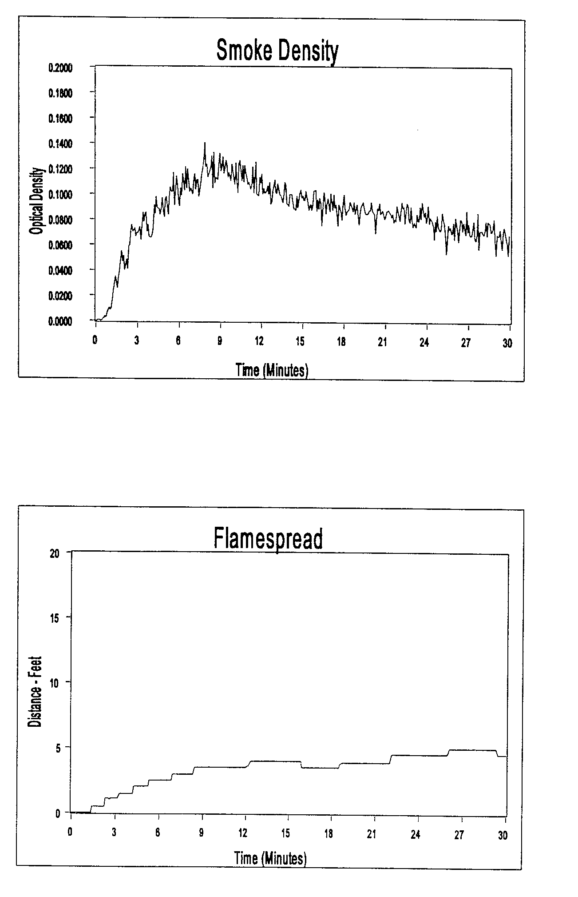

UL 1256 REPORT
CLIENT: FLAME SAFE WOOD PRODUCTS SWRI PROJECT NO: Ol-2303-137a
DAILY TEST NO: 5
-1200 !::.
~1000 Iii 800
Q.
~:y
2000l I I
1800 1800 1400
EXDosed TC at 24 Feet
o T
12 lS 18 21 24 21 30
Time (Minutes
6 of 6
